**UNIX Lab Assignment 7**

Name: Sreekesh Iyer Roll No. 24

**Advanced Shell Script**:

1. **Shell Script Program To Check Whether Given File Is A Directory Or Not**: **Code in adv1.sh**:

PASSED=$1

if [ -d "${PASSED}" ] then

echo "${PASSED} is a directory"; else

if [ -f "${PASSED}" ] then

echo "${PASSED} is a file"; else

echo "${PASSED} is not valid"; f

f **Output**:

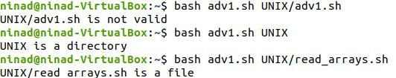

1. **Shell Script Program To Count Number Of Files In A Directory**: **Code in advsh.sh**:

PASSED=$1

if [ -d "${PASSED}" ] then

echo "Number of files in $(fnd "$@" -type f | wc –l)" f

**Output**:

